**BACnet/MSTP Adapter Setup**

**Building Automation Controls network/M**aster - **S**lave **T**oken **P**assing

**I. Wiring connections:**

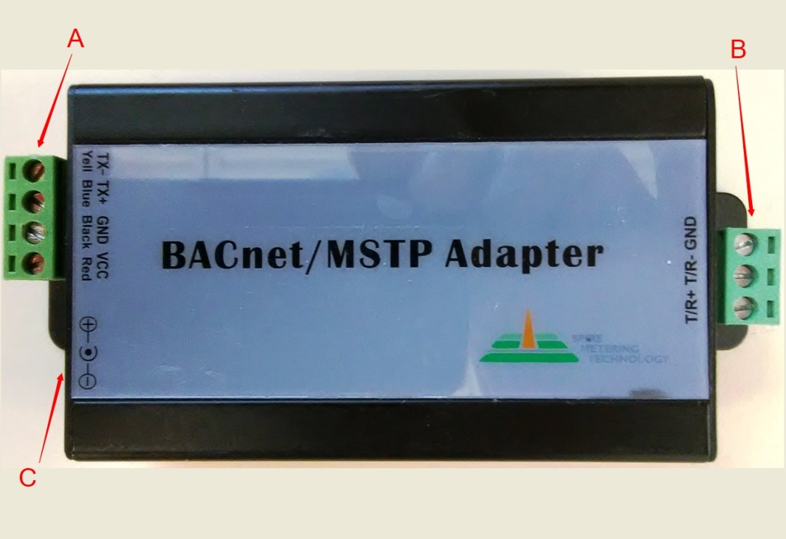

Description of ports:

**A** Contains four ports at the top left corner which are from top to bottom：

TX485- (Yellow) TX485+ (Blue) GND (Black) VCC (9VDC to 12VDC out) (Red) The VCC output is used to power a 280W or 280T meter cap interface electronics.

The TX485 ports connect to Meters that have the RS485 interface.

**B** Connects to a RS485 BACnet interface: GND, T/R - and T/R+ (usually to a concentrator), Building Monitor System (BMS), or field server interface.

**C** Is a round jack for the power supply voltage input (9 VDC to 12 VDC in), this powers the device and supplies the VCC output voltage on **A**.   
Note: When used with EF40, BACnet adapter can be powered by connecting F24V and FGND on EF40 to VCC and GND on adapter.

**Note: MODBUS/RS485 is not an input to a BACnet/MSTP adapter, only a RS485 output made for a BACnet/MSTP adapter works.**

Wiring connection example of a 280T (similar connection to the 280W meter):



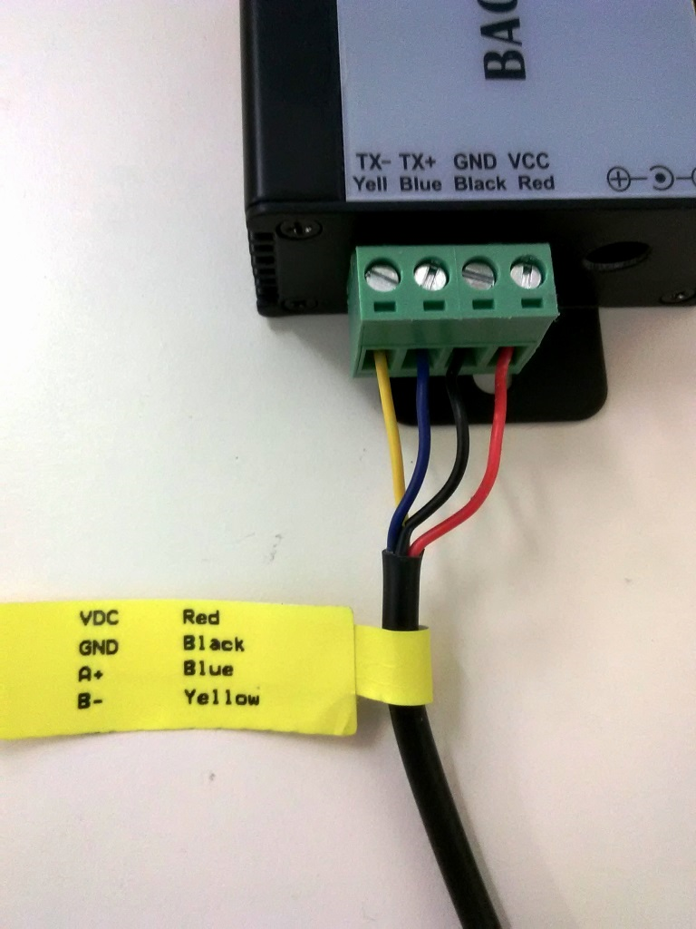

Note: the above cable is a RS485 output (not MODBUS)

**Ⅱ.** **BACnet Subassembly (To change Baud rate and Device ID or flash firmware)**:

To open the case, remove both green quick connects, then remove 4 Philips screws from the side with the power plug connection. The module can then slide out of the case (make note of how it slides out of the slot).

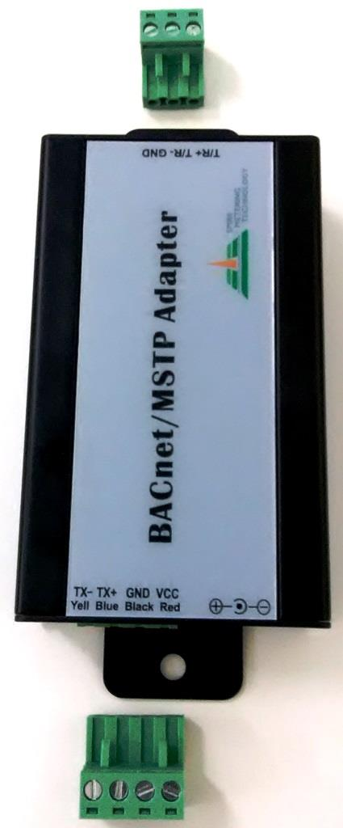 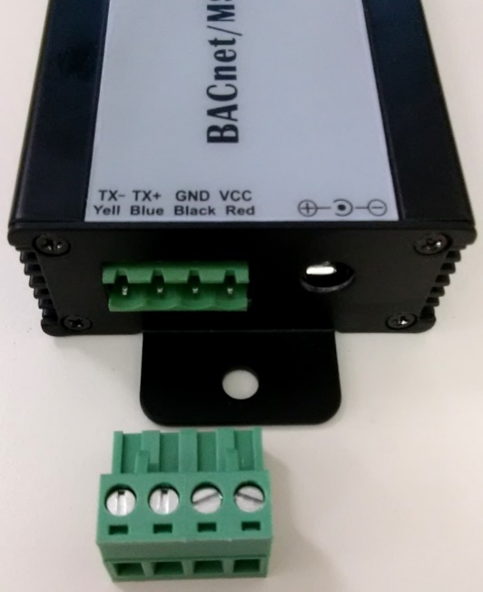

**Module removed from the case**

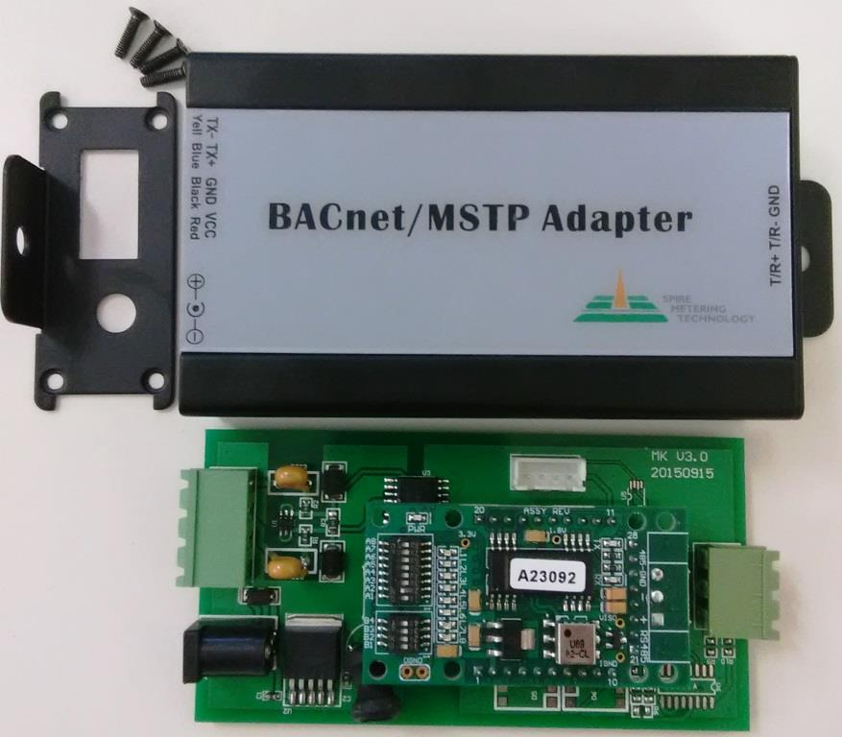

**Note: See “BACnet MSTP Work Instruction - EF10 and TP10” on flashing firmware.**

**Ⅲ. MAC Address of BACnet (or BACnet ID)**

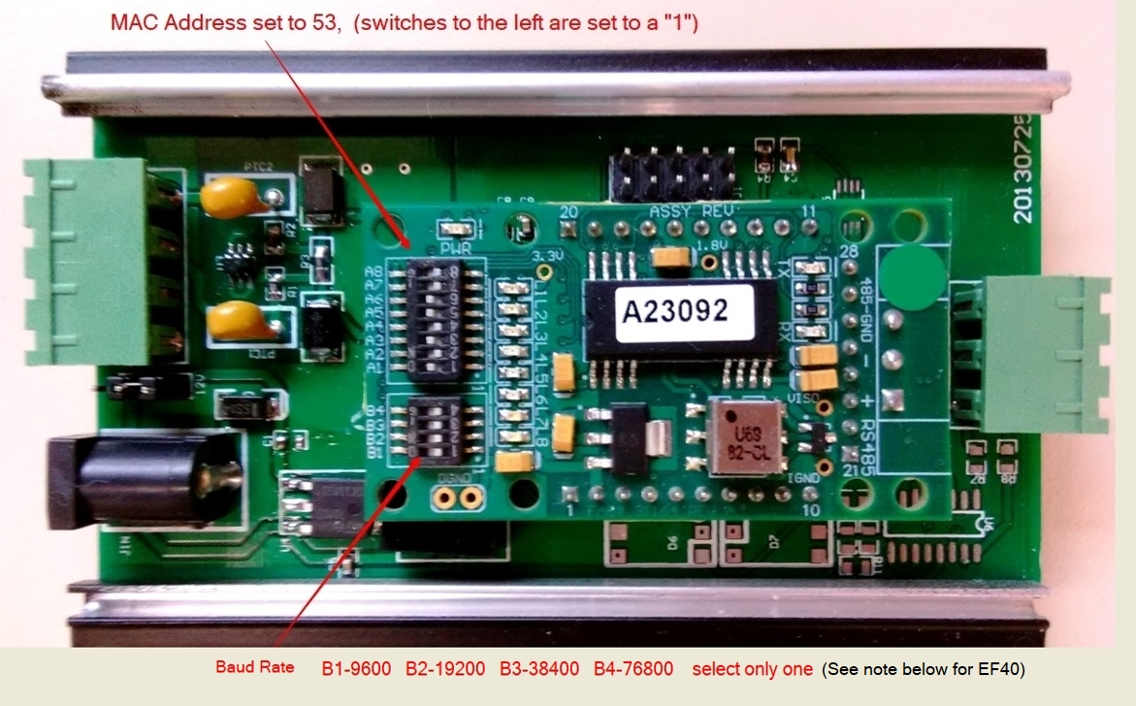**Instructions**：

1. The *default* MAC address is 0. The above module has been set to 53, which in binary

is (00110101). The address is set by turning on each bit to match the ID number

you require.

Switch A8 ---------------to---------------A1

128 64 32 16 8 4 2 1

0 0 1 1 0 1 0 1

32 + 16 + 4 + 1 = **53**

2. The *default* baud rate for the BACnet ***output*** is set to 0 and must be set to your intended baud rate. To set the baud rate on anything but an EF40 select only **one** switch from the following list:

9600 – B1 19200 – B2 38400 – B3 76800 – B4

***New Settings for EF40 adapter:*** B1      B2     B3     B4 Baud

Off     Off    **On**    Off – 9600

**On**     Off    **On**    Off – 19200

Off     **On    On**    Off – 38400

**On**     **On    On**    Off – 76800

**Additional notes:**

Online decimal to binary converter:

https://www.binaryhexconverter.com/decimal-to-binary-converter

**For Wall mount meters only:**

On an EF11-1 module, you tie the VDC 12V 1 ma power supply together for both BACnet and the meter, so it powers both modules. The BACnet module is then attached with Velcro to the inside back of the EF11 enclosure. Also use a 1-foot length of wire (TRX+, TRX-, GND) and wire BACnet output signals out with the power supply input cable. It is also good practice to mark the cable connections on the wires outside of the enclosure. This procedure is also used on other wall mount meters.

**Optional way to test BACnet adapters:**

To test the configuration, attach the output wires to a FieldServer adapter, the EF11 must be configured to Modbus RTU only, and a baud rate of 2400, Even,8,1 Also the FieldServer adapter must be set to match the baud rate of the BACnet module as programmed, using a discover command it should find the BACnet ID, and by using the FieldServer website, you can look at the lower bits of the serial number of the EF11 to verify it is communicating with the meter.

**All BACnet modules are programmed for the meter type:**

All BACnet modules must be programmed at the factory with the correct firmware to match the meter it is paired with, i.e. Mag meter, Water meter, BTU meter, or Wall mount meter.

**Additional power for Water meters:**

Water and BTU meters use an internal Lithium-thionyl Chloride (Li-SOCl2) battery which is **non**-rechargeable and powers the meter for many years. The additional power supplied by the BACnet adapter is only used to power the meters cap interface electronics, so the meter can interface to an external device.

**BACnet/MSTP Points Table: 1. Metric 2.English**

|  |  |  |  |
| --- | --- | --- | --- |
| Index | Variable Name | Data Type | Notes |
| 1 | Flow Rate | REAL | Unit:  1. L/h (Liters per hour) 2. Gal/m (gallons per minute) |
| 2 | Flow Total | INT | Unit:  1. m3 (cubic meters)  2. Gal (gallons) |
| 3 | Heat Energy Rate | INT | Unit:  W (Watts) |
| 4 | Heat Energy Total | INT | Unit:  KWH (Kilowatt Hours) |
| 5 | Supply Temp | REAL | Unit:  1. C (Degrees Celsius)  2. F (Degrees Fahrenheit) |
| 6 | Return Temp | REAL | Unit:  1. C (Degrees Celsius)  2. F (Degrees Fahrenheit) |
| 7 | SN# | BCD | Serial Number of meter |
| 8 | Meter Type | BCD | Type of meter:  TP10  EF10  280T  280W-CI  280W-R  280W-D  T-MAG  MAG888 |

**Note**: If no baud rate is set on the adapter it will autobaud to the speed of the interface, as long as the interface is set to any of the following baud rates (9600, 19200. 38400, 76800). If the interface baud rate is changed, the adapter must be power cycled for the autobaud function to work correctly. Make sure all attached adapters are running the same baud rate.

**Chart to determine 280 meter output type**

|  |  |  |
| --- | --- | --- |
| Type | No. of Wires | Colors |
| **Encoder** | 3 | Black, Red, Yellow |
| **MBus** | 2 | Red, Black |
| **Pulse (with battery)** | 2 | Yellow, White |
| **Pulse (No battery)** | 4 | Yellow, White, Red, Black |
| **Modbus *or* 485 bus** | 4 | Red, Black, Blue, Yellow (See label on wire) |
| **Modbus + 4-20mA** | 6 | Red, (Orange or Brown, White, Black, Yellow, Green |

**Pinout for the output type**

Encoder (3 wires)

Black Gnd

Red Vdc

Yellow D+

MBus (2 wires)

Red MBus +

Black MBus –

**Pulse (with battery)**  (2 wires)

Yellow B-

White A+

**Pulse (without battery)**  (4 wires)

Red Vdc

Black GND

Yellow B-

White A+

Modbus *or* 485 only(4 wires) “Check label on the cable”

Red Vdc

Black GND

Blue A+

Yellow B-

Modbus + 4-20ma (6 wires)

Red Vdc

Orange Ao+ (After June 1, 2018 the color may also be Brown)

White Ao-

Black GND

Yellow 485B

Green 485A